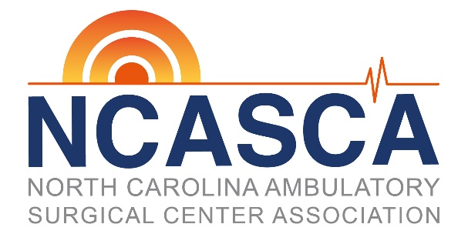
Maximize Your
Marketing Efforts

Sponsorship and Advertising Opportunities
Designed for North Carolina ASC Vendors
About NCASCA Members
NCASCA Members are ASC administrators, medical and nursing directors, business managers and CEOs. NCASCA members are active spenders specifically seeking your services.
NCASCA Vendor Membership - $1500 per year
● Receive an electronic listing of all licensed ASCs in North Carolina.
● Receive NCASCA Communications, including emails, newsletters and a members-only website.
● Opportunities to attend member meeting and luncheons.
● 20% discount on any ONLINE marketing opportunity listed below
● Year-long recognition on the NCASCA website.
● Recognition in the Today, NCASCA’s quarterly newsletter.
● 10% discount on advertisement in NCASCA’s quarterly newsletter.
NCASCA Meeting Sponsorship
● Sponsorship fees for the membership meetings are $1000 per meeting date.
● Fees include a company logo on marketing materials for meeting, 6 ft table for display, introduction
during the meeting and a list of attendees.
NCASCA Newsletter Advertising
NCASCA publishes an electronic newsletter 3 times a year and a print newsletter in the 4th quarter. Ad deadlines are February, May, August & November.
● Various ad sizes are available from $125-$275 depending on format of newsletter
● Artwork should be a .PDF, .EPS or JPG file. Recommended resolution is 300 dpi for all files.
NCASCA Online Opportunities
● Exclusive Email Blast - $1500 per blast
● NCASCA sends an exclusive email on your behalf to the NCASCA member list
● Specs: 660w x (no height limit)
● NCASCA Member Email Ads - $300 per month
● Feature your company with a linked ad image in each NCASCA member communication sent. This
is an exclusive footer banner ad placement.
● Specs 660w x150h
● Website advertising
● Home page - $200 per quarter (one year discount available)
● Home page ads are rotating – no more than 6 ads will rotate at any time
To reserve your sponsorship or advertising opportunity contact Cory Gruver
Cory@ascmember.org * (888) 526-9450

